**Code14: while loop**

#include <stdio.h>

#include <stdlib.h>

int main(){

int index = 1;

while(index <= 5){

printf("%d\n",index);

index++;

}

return 0;

}

Output:

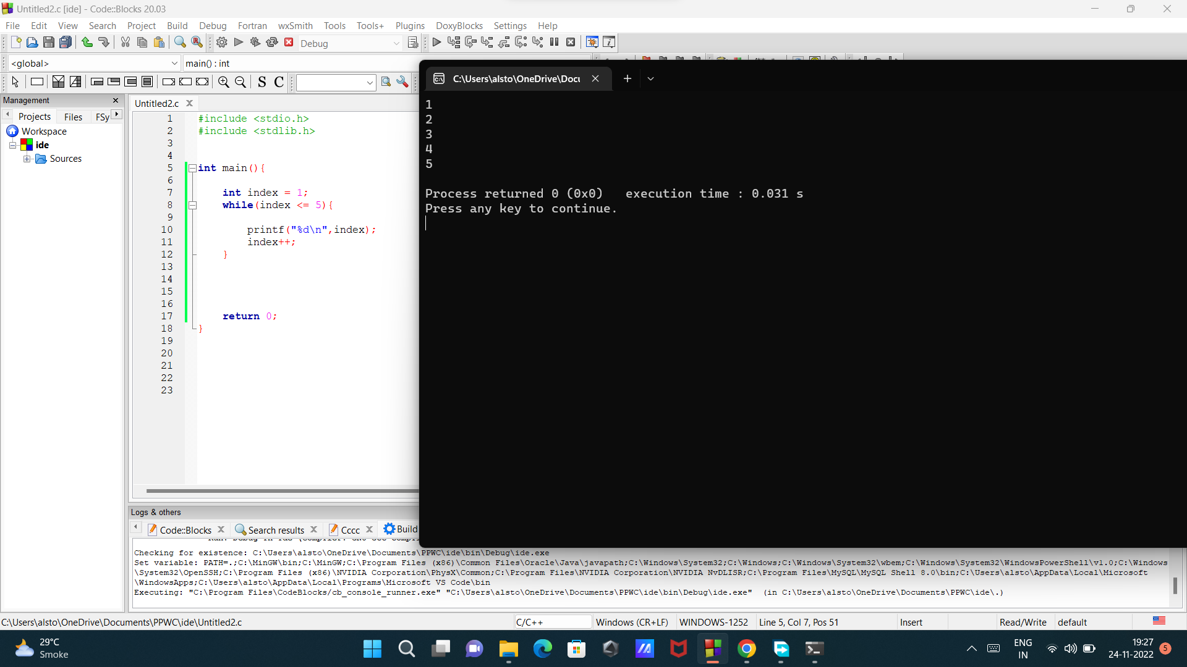

**Code15:do-while**

#include <stdio.h>

#include <stdlib.h>

int main(){

int index = 6;

do{

printf("%d\n",index);

index++;

}

while(index <= 5);

return 0;

}

Output:

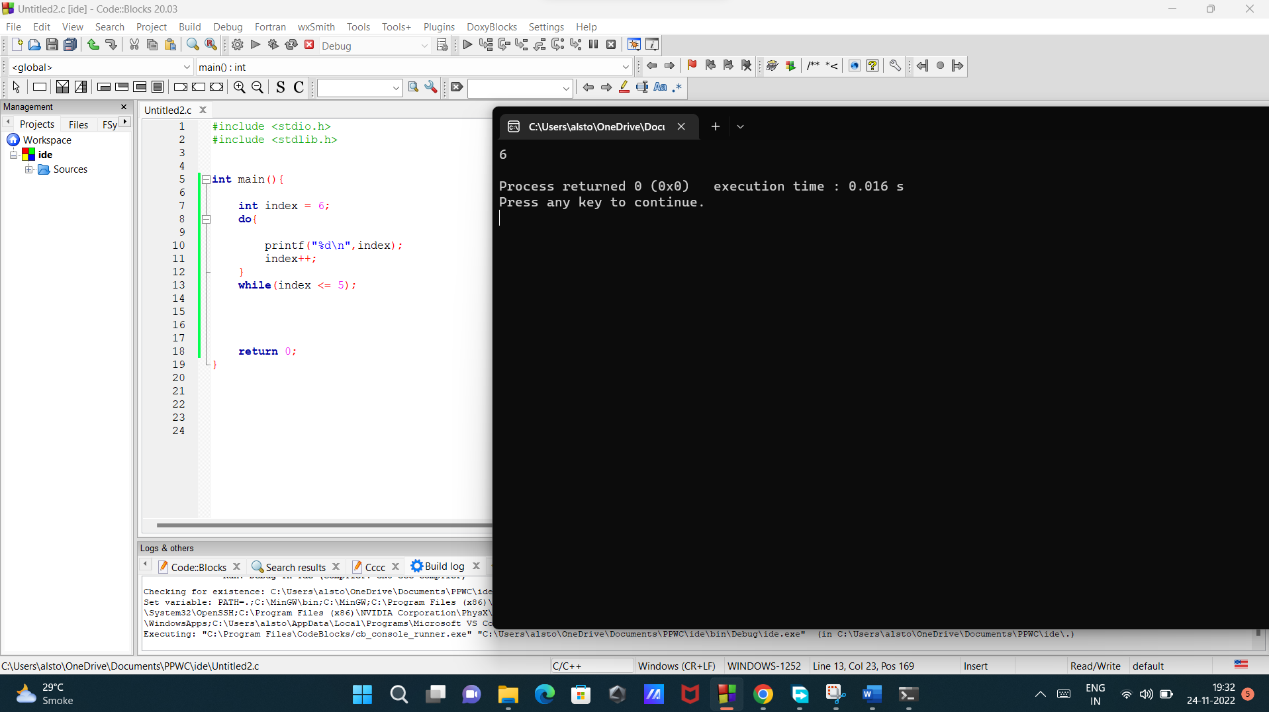

**Code16: Building a guessing game.**

#include <stdio.h>

#include <stdlib.h>

int main(){

int secretNumber = 5;

int guess;

while(guess != secretNumber){

printf("Enter a number:");

scanf("%d", &guess);

}

printf("You win!");

return 0;

}

Output:

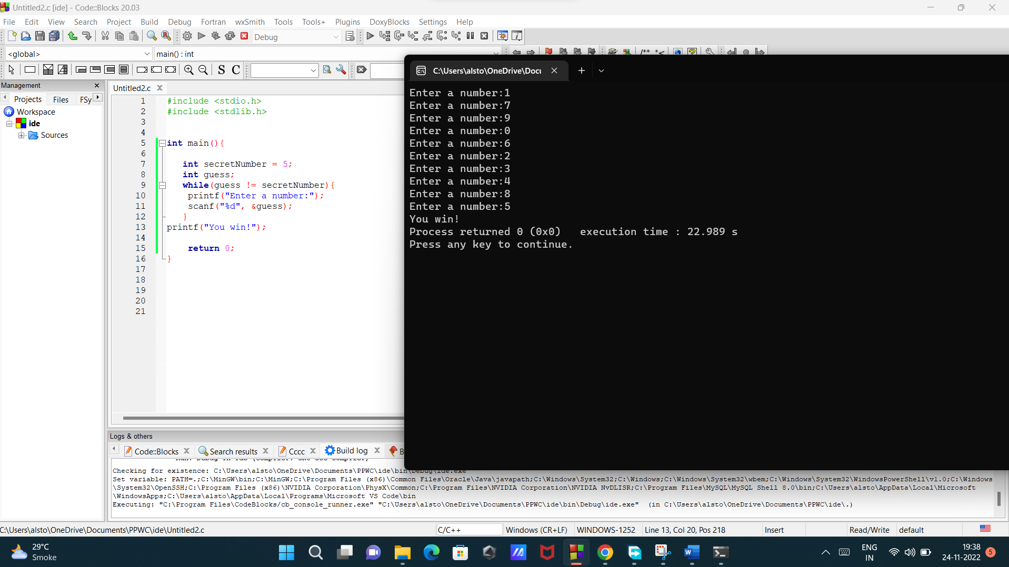

**Code17: Building a guessing game(with limited tries).**

#include <stdio.h>

#include <stdlib.h>

int main(){

int secretNumber = 5;

int guess;

int guessCount = 0;

int guessLimit = 3;

int outofGuesses = 0;

while(guess != secretNumber && outofGuesses == 0){

if(guessCount < guessLimit){

printf("Enter a number:");

scanf("%d", &guess);

guessCount++;

}else {

outofGuesses = 1;

}

}

if(outofGuesses == 1){

printf("Out of guesses");

} else{

printf("You win!");

}

return 0;

}

Output:

